
2015 USATF REGION 12
Junior Olympic Track & Field
Championships

July 7-11, 2015
McMurry State University
1650 War Hawk Way
Abilene, TX 79605

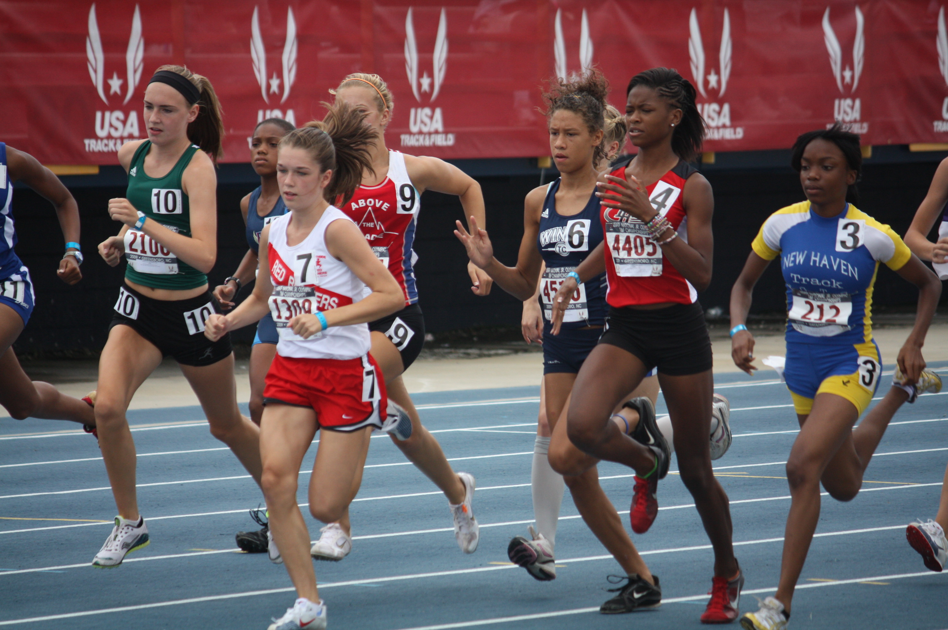
Age Divisions & Eligibility Requirements:

Age Divisions
8 & under (born 2007 +)
9 - 10 (born 2005-2006)
11 - 12 (born 2003-2004)
13 - 14 (born 2001-2002)
15 - 16 (born 1999-2000)
17 - 18 (born 1997-1998)
* athletes born in 1996 are also eligible if they do not turn 19 on or before 8/2/2015

Individuals: Only U.S. citizens, aliens living in the United States and foreign exchange students are eligible to compete in these Championships. See the USATF Rules for more information and exceptions. A competitor must compete in his/her age division only. There will be no "moving up" in any events, including relays. Competitors in the 8 & Under, 9 - 10 and 11 - 12 age divisions may compete in a maximum of three (3) events, including relays. Competitors in the 13 - 14, 15 - 16 and 17 - 18 age divisions may compete in a maximum of four (4) events, including relays. Combined events are not included in the event count. All athletes must be 2015 members of USATF in good standing.

Relay Teams: Only registered 2015 USATF member clubs may enter a relay team(s). All athletes representing the club must be affiliated with and members of that club as part of their USATF membership. Visit www.usatf.org/membership.

ENTRY PROCESS:

Individual Entries: $7.00 per event
Relay Entries: $28.00 per relay team
Decathlon/Heptathlon: $20.00 per event
Triathlon/Pentathlon: $15.00per event

Club Administrators and Unattached Athletes should register online at CoachO.com by July1, at 11:59 pm. Late entries will not be allowed. Online registration opens 6/23/2015. Fees must be paid online by the close of registration. Accuracy of data entered is the responsibility of each club and/or athlete. Please validate data within Coach O for accuracy prior to submitting entry. An instructional video on the online registration process may be accessed by visiting, http://coachoregistration.com/meet/entry/assets/videos/usatf/index.html.

WAIVER: All athletes who participate in the USATF Junior Olympic Program must complete the Junior Olympic Participant Waiver and Release form. This form is already integrated in the online entry system and can be completed electronically; it can also be obtained via your association. All forms must be submitted at the first round of the Junior Olympic series.

AWARDS: USATF Junior Olympic medals will be awarded to the top three (3) individuals and the top three (3) relay teams in each event of each age division.

ADVANCEMENTS: The top 6 individuals and relay teams in each event of each age division will advance to the USATF Region 12 Championships to be held on 7/7/-7/11/2015 at McMurry State University, Abilene, TX. . Advancements must be completed by declaring at coachO.com July 1, 2015 at 11:59 pm. Declaration will open on 6/22/2015.

The National Junior Olympic Championships will be held from Monday, July 27th to Sunday, August 2nd at Hodges Stadium at the University of North Florida in Jacksonville, FL. The top 5 athletes at the Region 12 Championships will qualify for the National Championships, in combined events the top 2 athletes will qualify. Information is available at:
http://usatfregistration.com/entry/tx_usatfyouth26

Schedule of Events (Please note schedule correction to Long Jump 9-12G/B)

Tuesday: July 7 Events Cancelled due to foul weather. Scheduled Events moved to Wednesday July 8.

8:30 am 9:30 am 10:00 am 1:00 pm

Heptathlon15/16-17/18 Decathlon 15/16-17/18 Pentathlon13/14 Triathlon 9/10
100mh 100m 100mh Shot Put
High Jump Long Jump Shot Put High Jump
Shot Put Shot Put High Jump 200/400m
200m High Jump Long Jump
400m 800/1500
FIELD EVENTS

12:00 pm

Long Jump 8U G B F

RUNNING EVENTS

12:00 pm 4x800 Relay 11-12 GB, 13-14GB, 15-16 GB, 17-18 MW F

FIELD EVENTS

3:00 pm
Hammer 15-16 G, 17-18 W, 15-16 B, 17-18 M F

Thursday: July 9 (Revised 7/7/2015 @11:30 am)

8:00 am 8:15 am 9:30 am

Pentathlon 11/12 Decathlon 15/16-17/18 Heptathlon 15/16-17/18
80mh 110mh Long Jump
Shot Put Discus Javelin
High Jump Pole Vault 800m
Long Jump Javelin
800/1500m 1500m

RUNNING EVENTS

8:30 am 3000m 11-12 GB, 13-14 GB, 15-16GB, 17-18 WM F

10:00 am 4x400m relay ALL P

1:00 pm 110mh 15-16 B, 17-18 M P

1:30 pm 100mh 13-14 GB, 15-16 GB, 17-18 WM P

2:20 pm 80mh 11-12 GB P

3:00 pm 100m ALL P

5:00 pm 200m ALL P

FIELD EVENTS

8:30 am 2:30 pm

Long Jump 17-18 W M Long Jump 9-10B, 11-12B, 13-14 B F

Triple Jump 15-16 GB High Jump 13-14 GB F

High Jump 9-10 G, 11-12 G Shot Put 15-16G 17-18 W F

Shot Put 8U B, 9-10B, 11-12 B Javelin 13-14G,15-16G,17-18W F

Pole Vault 13-14G, 15-16G, 17-1 W Shot Put 8U G, 9-10 G, 11-12 G F

11:30 am

High Jump 9-10B, 11-12 B F

Discus 11-12 GB, 13-14 GB

Friday: July 10

RUNNING EVENTS

8: 00 am 2000m Steeplechase 15-16 GB, 17-18 WM F

9:00 am 110mh 15-16 B, 17-18 M F

100mh 13-14 GB, 15-16 G, 17-18W F

80mh 11-12 GB` F

4x100m relay ALL P

800m ALL F

100m ALL F

400m ALL P

200mh 13-14 GB P

400mh 15-16 GB, 17-18WM, P

200M ALL F

FIELD EVENTS

8:30 am

Pole Vault 13-14B, 15-16B 17-18 M F

Long Jump 15-16 GB F

Triple Jump 17-18 M F

High Jump 17-18 W F

Shot Put 13-14 GB F

Mini Javelin 8U.B, 9-10 B, 11-12 B F

Javelin 13-14 B, 15-16 B, 17-18 M F

11:30 am 2:30 pm

Long Jump 9-10 G, 11-12 G 13-14 G High Jump 15-16 G F

Triple Jump 17-18 W Discus 15-16 B, 1718 W M F

High Jump 15-16 B, 17-18 M Triple Jump 13-14 G B F

Shot Put 15-16 B, 17-18 M F

Discus 15-16 G, 17-18 W F

Mini Javelin 8U G, 9-10 G, 11-12 G F

Saturday: July 11

RUNNING EVENTS

8:30 am

1500m Race Walk 9-10 G, B, 11-12 GB, F

3000m Race Walk 13-14-G B F

3000m Race Walk 15-16 GB, 17-18 YM F

10:00 am

4x100 m relay ALL F

400 m ALL F

200mh 13-14 GB F

400mh 15-16 G, 15-16 B, 17-18 W, 17-18M F

1500m ALL F

4x4m relay ALL F

IMPLEMENT WEIGH-IN: 7:00 at site to be determined. All throwers with events on Thursday will be evaluated first.

EVENT CHECK-IN: There will be separate check-in areas for Running and Field events. Athletes must check in at these designated areas 45 minutes prior to the event's scheduled starting time. All athletes will be required to remain in the designated warm-up areas after checking in. No coaches will be allowed within this area and it will be secured.

COMPETITION BIB NUMBERS: The bib number must match the competition number on the “Team Entries” printout. All competitors must wear their assigned bib numbers during competition on the front on their jerseys only. Please make sure your athlete is wearing the correct number. An athlete must wear their bib numbers and wristbands to compete.

LOST BIBS & WRISTBANDS: If an athlete loses the bib or wristband a replacement can be purchased for a fee of $6.00 each. Packet pick up will be located at the host hotel the night before the meet from 7-9 pm and every morning of the meet at the gate out front on the first day of the meet and at the gate on subsequent days at 7:30 am.

EVENT RESULTS: During competition, event results will be posted near the press box and on the ground level near the entrance. Posted results are for everyone’s observation. PLEASE DO NOT REMOVE POSTED RESULTS. Event results will be posted online.

PROTESTS: Protests relating to matters which develop during the conduct of the competition must be submitted to the Protest Referee at once and not later than 30 minutes after a result has been posted, (rule 146). Only violations of the current USATF Rules of Competition may be protested. The protest should be written on the Protest Form with the proper USATF rule sited. Protest fees are $100 CASH ONLY, NO EXCEPTION. Fees and completed protest forms can be turned in at the ticket booth. The protest fee will be reimbursed if the is upheld if protest is upheld.

RULES – CONDUCT & FACILITY: ZERO TOLERANCE FOR MISCONDUCT FOR ATHLTES, COACHES AND SPECTATORS THERE ARE NO EXCEPTIONS & WILL BE ENFORCED. UNATHORIZED PERSONNEL ARE NOT ALLOWED ON THE TRACK, IN THE FIELD EVENT AREA & MOST OF ALL IN THE CLERKING AREA.

GATE ADMISSION FEES: $7.00 General Admission.

DIRECTIONS: Use your GPS until further notice.

PARKING: FREE

CONTACT:
Name: Toni Nichols
Phone Number: 214-803-9633
E-mail: tnichols70@sbcglobal.net

